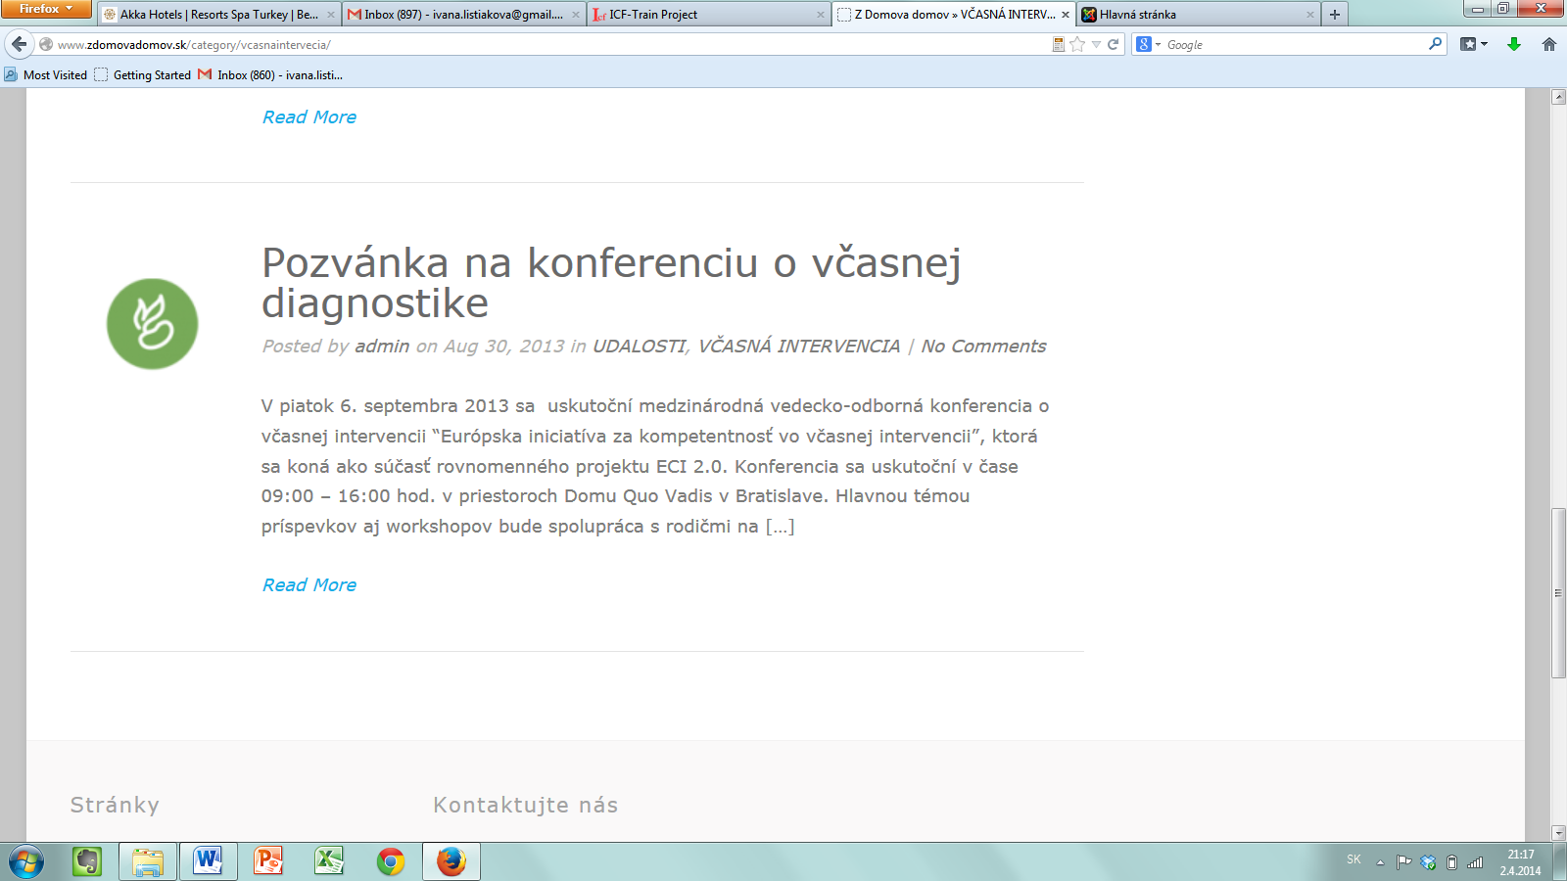
http://www.zdomovadomov.sk/category/vcasnaintervecia/

